

AAO Core Pre UAT Test Summary Report

Version: 2.0
Updated: 09/17/2013
Author: IBM Global Services

Revision History
Revision Number | Date | Revision Author | Description
0.1 to 1.0 | 09/16/2013 | Prithwiraj Chakraborty | Changes will be not tracked.
1.0 to 2.0 | 09/17/2013 | Prithwiraj Chakraborty | Added two defect charts by function area

Distribution
Name | Title | Sign-off Required

Table of Contents
1. Purpose 4
2. Intended Audience 4
3. Overview / Executive Summary 4
4. Test Effort Summary 6
4.1 Test Case Execution Summary 6
4.2 Test Execution Summary by TACs 6
5. Defect/Issue Summary 6
6. Analysis and Conclusion 8
Appendix A – Lesson Learnt 9
Appendix B – Open / Deferred Issues and Defects 9
Appendix C – Open / Deferred Issues and Defects 12

Purpose
This document is the Final AAO Core R1 Pre UAT Report for the AAO Core Project.
The key goals of this report are to:
- Provide a summary of the test execution and results
- Evaluate the test outcome
- Give recommendations with regards to overall test approval

Intended Audience
The target audience of the document includes all parties interested in or involved in testing the AAO Core.
The following have been identified as the audience for this document.
- IT Test Team
- Project Managers
- Business Analysts
- Senior Leadership
- Developers
- Data Architects
- Systems Architects

Overview / Executive Summary
This Test Report of the AAO Core Project provides insight into actual testing achievements and capability associated with the Pre UAT Stage of Testing.
The flow of AAO Core Pre UAT Testing was as follows:
3.2 Work-flow for System Test

Development
&
Dev Testing
Build Verification test
(Test Team)
System Test (ST)
(Test Team)

Regression Test

Stable Functions to Pre UAT
(UAT users)

Workflow Notes:

- Development & Dev Testing – Cycles started with a delivery of Code containing the AAO Core functionality which is unit tested and sting tested by the Dev team in Dev environment before it goes to the SIT environment.
- BVT Test – The build was implemented in the SIT environment. A One hour build verification testing is done on the SIT environment to check the stability of the build.
- SIT Test – Continuous SIT testing happened on the released build. If a function meets the SIT exit criteria (no major or critical defects), moved to UAT environment for Pre UAT users.
- Pre UAT Cycle started approximately 08/19/2013 through 09/06/2013.

Test case Execution Goals:
- Pre UAT Cycle – 104 Total Test cases Planned for Execution

TAC Name | Total Test Cases Planned
AIS | 11
BAO | 16
CAMS | 16
Oracle | 20
SAP | 19
Test | 22

Test Effort Summary

4.1 Test Case Execution Summary

Start Date / End Date | Planned | Passed | Failed | Blocked
Aug-19 2013  Sep-06 2013 | 104 | 10 | 73 | 21

Besides the “Passed” and “Failed” status, a test case is marked as “Blocked” if it cannot be executed due to one of the following reasons:
- Components are not delivered and the function is not available.
- Defects were found that will be corrected in a future release.
- Test data is not available or test environment is not set up.
- There are functional defects that impair test case execution and completion.

4.2 Test Execution Summary by TACs
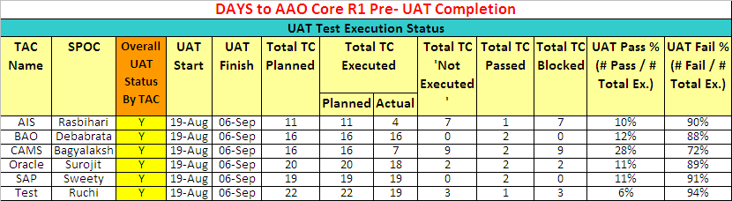

Defect/Issue Summary
A total of 97 issues/defects were reported during AAO Core Pre UAT out of which 21 defects/issues are identified as potential CRs.
“open” and/or “deferred” issues have been documented and presented to the Pre UAT users and Platform Development Team.
The table below illustrates the total defect/issue statistics by function area and severity:
Functional Area | 1-Critical | 2-High | 3-Medium | 4-Low | Total
Core to RTC |  | 2 | 4 |  | 6
Defect creation | 1 | 2 | 2 |  | 5
Deliverable Template | 2 | 4 | 7 |  | 13
Effort Estimation |  | 1 |  |  | 1
Issue |  | 1 | 3 | 1 | 5
Metrics | 1 |  |  |  | 1
Modify wbs | 3 | 2 | 2 |  | 7
Open Proj | 1 | 1 | 1 |  | 3
Project Management | 1 | 3 | 4 |  | 8
Report |  |  | 3 |  | 3
Resource Management |  | 1 | 2 |  | 3
RTC |  | 2 | 2 |  | 4
RTC to Core |  |  | 1 |  | 1
Task View List |  | 1 |  |  | 1
Work Request | 3 | 5 | 12 | 3 | 23
Work Scheduler | 5 | 2 | 5 | 1 | 13
Total | 17 | 27 | 48 | 5 | 97

Figure1: defect/issue statistics by function area and severity (Critical and High)
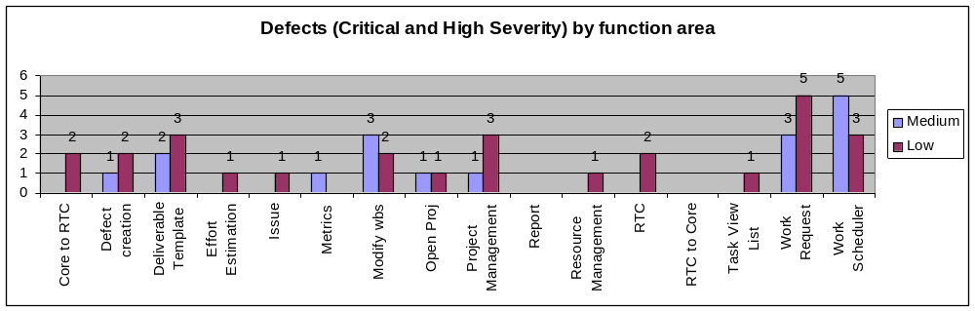
Figure2: defect/issue statistics by function area and severity (Medium and Low)
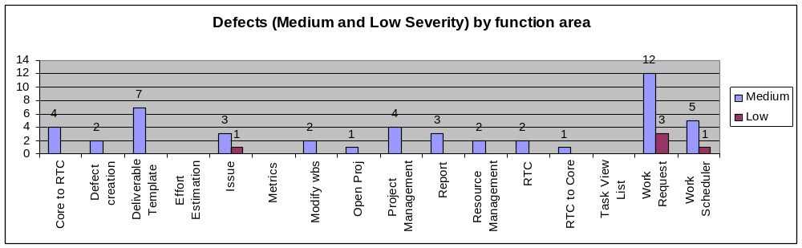

The table below illustrates the open defect/issue statistics by function area and severity:
Functional Area | 1-Critical | 2-High | 3-Medium | 4-Low | Total
Core to RTC |  | 1 | 3 |  | 4
Defect creation | 1 | 2 | 2 |  | 5
Deliverable Template | 1 | 3 | 6 |  | 10
Effort Estimation |  | 1 |  |  | 1
Issue |  | 1 | 3 | 1 | 5
Metrics | 1 |  |  |  | 1
Modify wbs | 3 | 2 | 2 |  | 7
Open Proj | 1 | 1 | 1 |  | 3
Project Management | 1 | 3 | 4 |  | 8
Report
Resource Management |  | 1 |  |  | 1
RTC |  | 1 | 2 |  | 3
RTC to Core |  |  | 1 |  | 1
Task View List |  | 1 |  |  | 1
Work Request |  | 2 | 5 | 2 | 9
Work Scheduler | 5 | 2 | 4 | 1 | 12
Total | 13 | 21 | 33 | 4 | 71

The table below illustrates the Change Request Defect statistics by function area and severity:
Functional Area | 1-Critical | 2-High | 3-Medium | 4-Low | Total
Core to RTC
Defect creation
Deliverable Template | 1 |  | 1 |  | 2
Effort Estimation
Issue
Metrics
Modify wbs
Open Proj
Project Management
Report |  |  | 3 |  | 3
Resource Management |  |  | 1 |  | 1
RTC |  | 1 |  |  | 1
RTC to Core
Task View List
Work Request | 3 | 3 | 6 |  | 12
Work Scheduler |  | 1 | 1 |  | 1
Total | 4 | 5 | 12 |  | 21

The table below illustrates the “Closed/Rejected” defect/issue statistics by function area and severity:
Functional Area | 1-Critical | 2-High | 3-Medium | 4-Low | Total
Core to RTC |  | 1 |  |  | 1
Defect creation
Deliverable Template
Effort Estimation
Issue
Metrics
Modify wbs
Open Proj
Project Management
Resource Management |  |  | 1 |  | 1
RTC
Task View List
Work Request |  |  | 2 | 1 | 3
Work Scheduler
RTC to Core
Report
Total |  | 1 | 3 | 1 | 5

Analysis and Conclusion
Upon conclusion of AAO Core Pre UAT all defects/issues were recorded. These records can be found in the RTC.
https://rcc-pok-idg-2642.cloud9.ibm.com:9445/ccm/web/projects/AAO%20Core%20Development%20Project%20Area#action=com.ibm.team.workitem.runSavedQuery&id=_OZwZgAMIEeOZpclA1a0nFg

Appendix A – Lesson Learnt

What process/practice worked well and should be repeated for future testing efforts?
- Testing performed by a dedicated test team from each TAC brought objective views and quality assurance focus.
- This was a guided Pre UAT with pre defined test cases uploaded in RQM. This helped us to get early feedbacks on the system and all the observations are captured in RTC.

What process/practice needs improvement?

- Ensure UAT Test cases are written based on the pre defined template provided by the platform development team. This will reduce the test case upload time to RQM.
- We need to ensure the UAT test cases are not too big. This is making the traceability very difficult.
- Platform development QA team needs one week to review the test cases provided by TACs. So we need to allocate total two weeks for QA review, rework and upload test cases to RQM.
- One week prior to UAT we need to upload master data to the UAT DB and access to the systems needs to be tested by the users to avoid any challenge during UAT.

Appendix B – Open / Deferred Issues, Defects and CRs
Severity | Defect ID | Summary
Critical | 6315 | WR/Sub WBS edit should be locked for download when one resource has already downloaded it for edit
Critical | 6308 | The work scheduler didnot function as expected - The Work-request was not assigned to resources
Critical | 6304 | SAP Deliverable seen under BAO TAC
Critical | 6303 | Unused Project ID on UAT Portal shows already occupied
Critical | 6293 | No China resource has got assigned after Invoke Work Scheduler
Critical | 6273 | Unable to edit Deliverable WBS
Critical | 6262 | Failing Test Case "SAP_TAC_TC_metric_generation_20" when executing Test Execution Record "SAP_TAC_TC_metric_generation_20_Sweety"
Critical | 6256 | UI for editing deliverables
Critical | 6252 | Issue, Defect and WPI not available for tracking
Critical | 6247 | CAMS TAC- Work request failing while sending deliverables to RTC
Critical | 6244 | Existing UI for deliverable creation
Critical | 6242 | Work Scheduler assignment should assign only the deliverables added by the user
Critical | 6227 | Workpacket Start date is other than the dates given in the deliverable template
Critical | 6158 | Different Workpacket assigned to same member at same time
Critical | 6023 | Deliverable WBS download from AAO Core Portal is erroneous
Critical | 6014 | Planned effort value in task changes when compared with original in OpenProj xml files
Critical | 6013 | Work Request creation in AAO Core - should allow multi TAC, multi service and multi location
High | 6301 | Defect, WPI and Issue templates should be complaint with the corresponding OPAL templates
High | 6286 | User does not have option to check the deliverables association with its parent WorkRequest/Sub WorkRequest in RTC
High | 6282 | No option for the user to remove/untag the deliverables from a WorkRequest/Sub WorkRequest
High | 6279 | How to log change requests
High | 6277 | The WS should assign an owner to the Deliverable
High | 6266 | Duration given in Deliverable template and duration seen while downloading Deliverable WBS is different
High | 6260 | Issues not reflecting into RTC
High | 6259 | Duplicate Work Request
High | 6255 | Deliverable template addition UI - all 5 complexity values are not available - only low, medium n high are available right now
High | 6251 | Missing Attributes in Deliverable and Task
High | 6246 | Deliverables already assigned should not be available in WR/Sub WR WBS edit
High | 6245 | Work Scheduler should only assign deliverables in a particular state
High | 6243 | Workpackets creation in AAO Core/RTC under deliverables
High | 6238 | Effort value gets changed while assigning a single Task to many practitioners
High | 6236 | Error while sending the Deliverables to RTC
High | 6234 | Failing Test Case "SAP_TAC_TC_work_request_wbs_edit_10" when executing Test Execution Record "SAP_TAC_TC_work_request_wbs_edit_10_Sweety"
High | 6229 | Not able to add Deliverable to WR while modifying workrequests
High | 6224 | No deliverable is being shown in a WR
High | 6223 | AAOWorkRequestPortlet and AAOWBSPortlet should be linked
High | 6220 | Deliverable template without Review and Rework tasks or MANDATORY tasks should not be allowed to be uploaded in AAO Core
High | 6219 | Option to add WPI and Defect should only be available in "Review" tasks
High | 6036 | Task Summary, parent deliverable, parent WR and planned date details not available in AAOTaskListPortlet
High | 6035 | Location attribute for Work Request creation
High | 6031 | Changes going away while uploading and downloading the WR WBS
High | 6021 | Failing Test Case "SAP_TAC_resource_calender_upload_03" when executing Test Execution Record "SAP_TAC_resource_calender_upload_03_Sweety"
High | 6012 | Unable to upload deliverable template with same role from multiple services
Low | 6258 | Work Scheduler should not take the dates from the deliverable templates but instead should take only from the Workrequest
Low | 6278 | Name of the xml file when we download should have the name of the WR or Sub-WR
Low | 6239 | Not able to see the Issues until we move to another WR and come back
Low | 6221 | Wrong Message displayed on the AAOWorkRequest Portet

Appendix C – Open / Deferred Issues and Defects

The test case results can be obtained from RQM from the following link:
https://rcc-pok-idg-2642.cloud9.ibm.com:9445/qm/web/console/RQM%20for%20CLM%20%28Quality%20Management%29#action=com.ibm.rqm.planning.home.actionDispatcher&subAction=viewTestCases&updateAction=clear-filter-selection

Sample Report Snapshot:
